**CENWP-OD-B 12 July 2023**

**MEMORANDUM FOR THE RECORD**

**SUBJECT: 23BON055 MFR AFF Valve 15 Sockeye Mortalities**

On the morning of 12 July, Columbia River Inter-Tribal Fish Commission (CRITFC) Biologists notified Bonneville Project Biologists of two sockeye salmon mortalities found on the Valve 15 trash rack in the Adult Fish Facility (AFF). The fish were scanned for PIT tags, inspected, and returned to the river.

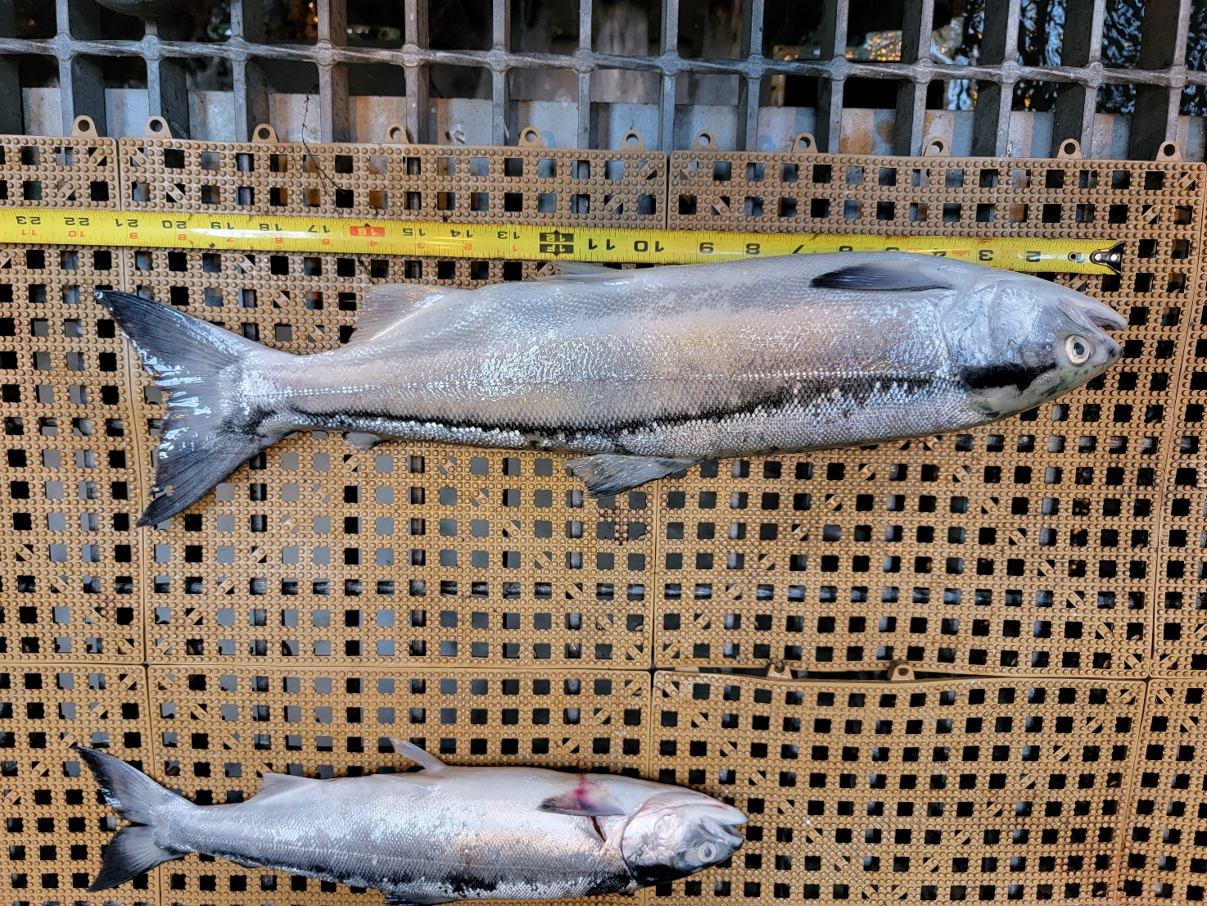Fish #1

1. Species – Sockeye Salmon (*Oncorhynchus nerka)*
2. Origin – Unknown
3. Length – 55.4 cm
4. Marks and tags – PIT #3DD.003E2BF279, Caudal fin clip
5. Marks and Injuries found on carcass – None
6. Cause/Time of Death – Occurred after being tagged by CRITFC crew at BON AFF on 07/11/23.
7. Future and Preventative Measures – unknown

Fish #2

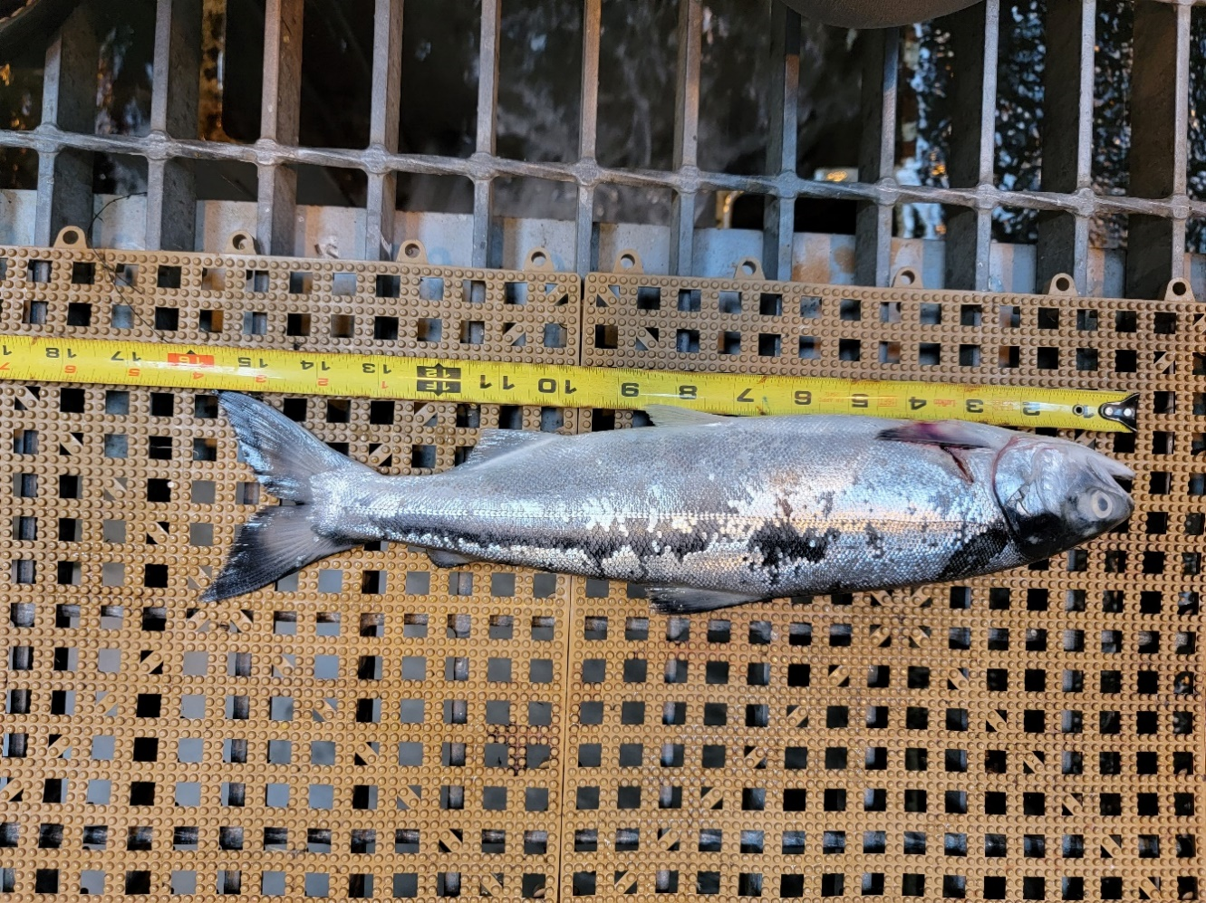

1. Species – Sockeye Salmon (*Oncorhynchus nerka*)
2. Origin – Unknown
3. Length – 40 cm
4. Marks and tags – None
5. Marks and Injuries found on carcass – Laceration behind left pectoral fin (see photo below)
6. Cause and Time of Death – Unknown
7. Future and Preventative Measures – None

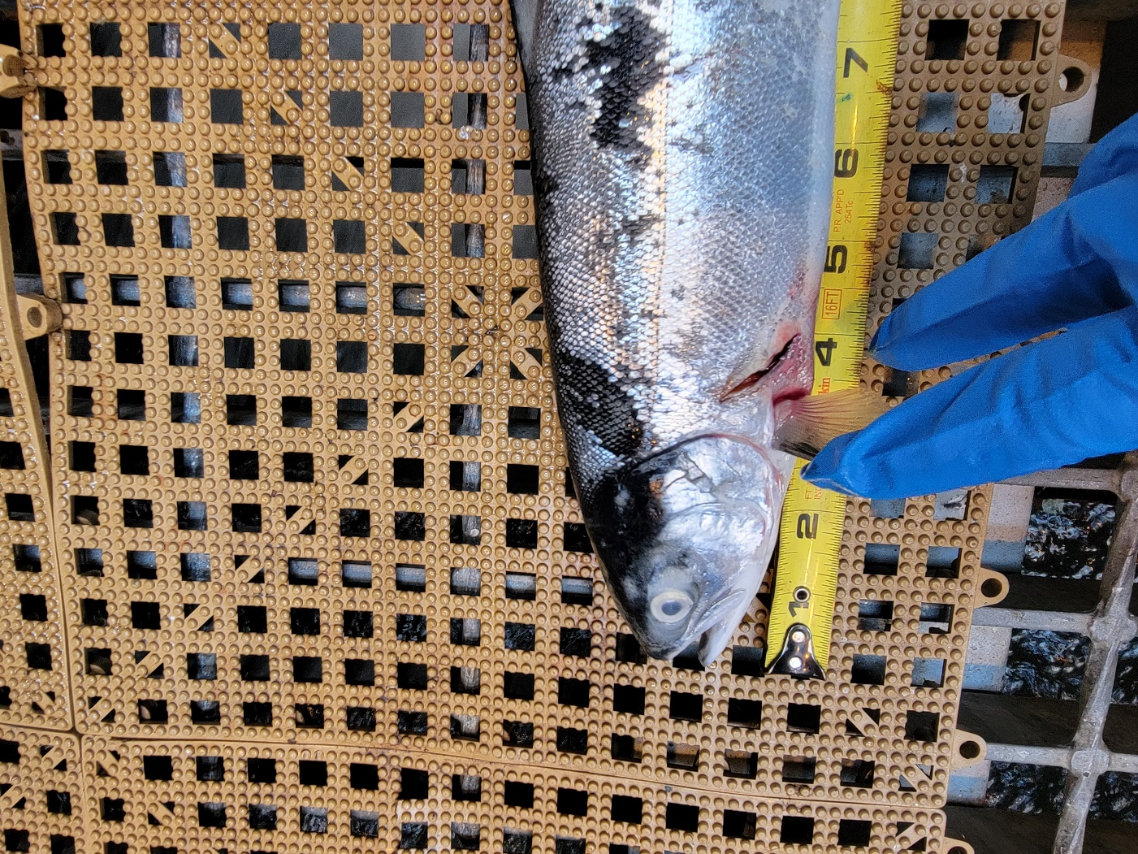

Sincerely,

Bonneville Project Fisheries